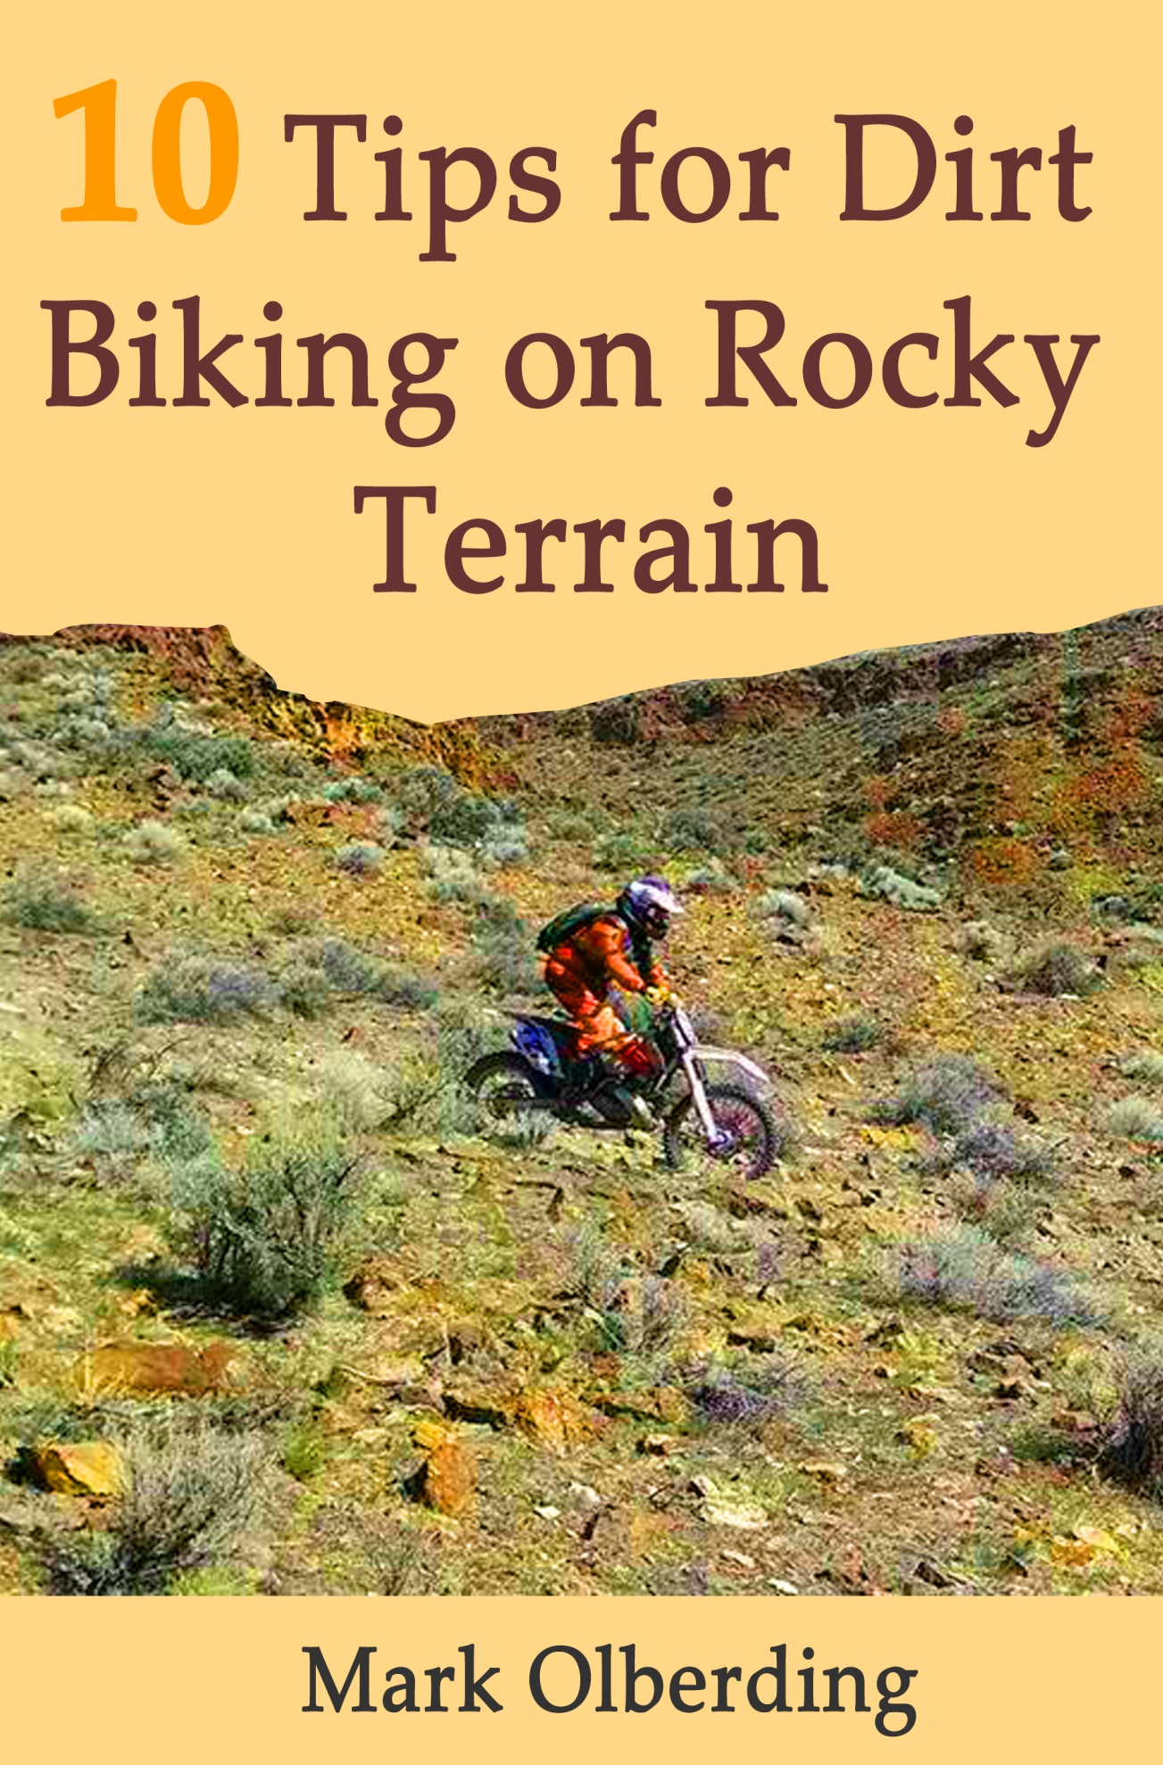
10 Tips for Dirt Biking on Rocky Terrain

Handling a dirt bike on rocky terrain can be a challenge. Knowing how to control the power of a dirt bike can also be a challenge even for the experienced biker. With my many years of riding and racing on these types of trails and terrain, I have come up with some basic strategies for maneuvering over rough terrain. Here are 10 tips to manage rough terrain more easily.
- To negotiate rocky terrain, first scan the area and look for the smoothest possible path. Then when you enter the path, grip the dirt bike with your legs and stand up. This will keep the bike somewhat straight. Do not sit down on the bike’s seat. Also, know that If you stare at a rock . . . you WILL hit that rock!

- If the rocks are really rough, your first reaction would be to look at your dirt bike’s front fender. Don’t do this! Take your eyes off the front of your bike and look around for the smoothest line. (Note: the closer to the bike you look, as opposed to looking off at a distance on the trail, the slower you will go.)

- When riding at faster speeds through the terrain, be careful of plowing through sage brush or other small bushes. Rocks live behind bushes and you’ll soon find yourself doing a big flying W.

- I typically run 15 psi of tire pressure at my shop the night before I ride. I know this is not the same as checking the pressure on your tires when you’re riding (i.e. at certain altitudes and temperature), however, this definitely works for me. I can count on one hand the number of flats I have had during my 40 years of riding and racing on Idaho terrain.

- Keep your body weight centered on the bike most of the time. However, if there are bigger rock ledges you need to get over, lean back a little. Accelerate a little and pull the handle bars back so you won’t find yourself going over the handlebars.

- Watch some trial riding videos or, better yet, ride a trials bike if you get a chance. It will definitely help with your balance.

- Especially when riding rocky terrain, always remember to keep up your momentum. Instinct tells you to stop whenever the rocks become bigger. If you do stop, you can stall and tip over. Do not stop - do not panic! You need momentum to get you through areas where the front end of the bike will drop. You do not want your front end to get stuck up in a hole.

- Sometimes, you find yourself stalling through a rough, rocky spot on the trail. Remember that your clutch action has to be very smooth. Keep your fingers on the clutch at all times so you can easily pull the clutch when you need to. If there is an obstacle, do not hesitate to give more power to the bike. Be sure to keep your other finger on the front brake. You would use that if you need to stop or slow down the bike in a hurry. A Rekluse clutch (www.rekluse.com) is worth considering and can be very helpful in these types of gnarly rock sections.

- When riding in the mountain rocks, a soft compound rear tire or rear trials tire will help with your maneuvering. However, the drawback to a running a trials tire is they don’t stop well and they do have poor traction in the mud and/or snow.

- The last and final tip I would recommend is to follow my Bench Racing Blog at www.obielinkguard.com. I intend to give you good, up-to-date content with regard to dirt bike riding and racing, and tips for protection and maintenance of your bike. I also intend to give good advice and tips with respect to being a better, more efficient rider/racer and keeping your bike investment at a premium with linkage protection. Remember . . . protection is good!

About the Author:
Mark Olberding has been riding and racing in Idaho for the past 40 years. Mark received his Pro Motocross License in 1983 and has received many first place finishes throughout his racing career. His most recent racing accomplishments were placing first in the Master’s Class and 15th overall at the 18th Annual Oreana 100 Hare and Hound, and placing 1st in the “A” Super Senior Class and 32nd overall at the 2014 National Hare and Hound in Murphy, Idaho.

(Pictured on the front cover is Mark negotiating a rocky section at the 2014 National Hare and Hound.)

